**Visual Studio Code Installation Guide**

**Quicklinks:**

Installation Guide for Windows

Installation Guide for Mac

### Installation Guide for Windows

1. Go to <https://code.visualstudio.com/download>
2. Click on the **Windows** option on the download site

w

1. Download **Visual Studio Code for Windows**
2. After clicking on the Windows option on the download site, **“VSCodeUserSetup-x64.1.71.2.exe”** will be installed

(Note: there might be newer versions at the time you are installing)



1. Start the setup by clicking on the file downloaded
2. Select **“I accept the agreement”** and click **Next**

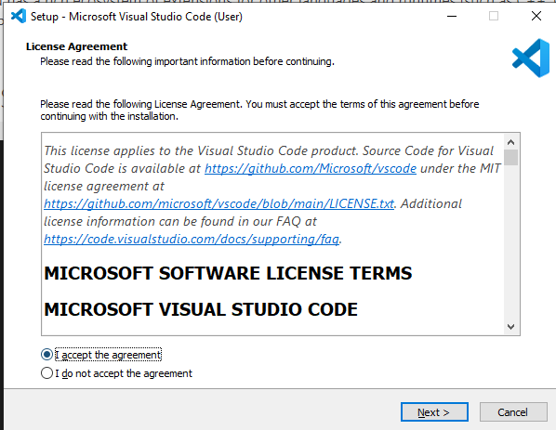

1. Leave the installation path as default. Click on **Next**

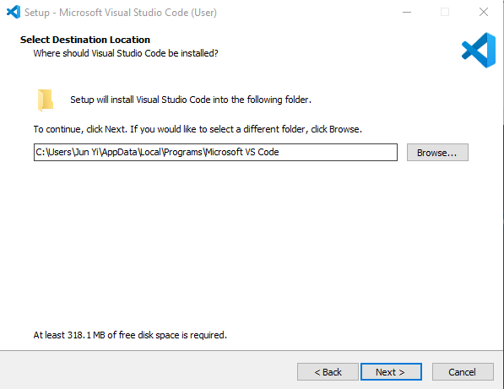

1. Leave this page as default. Click on **Next**.

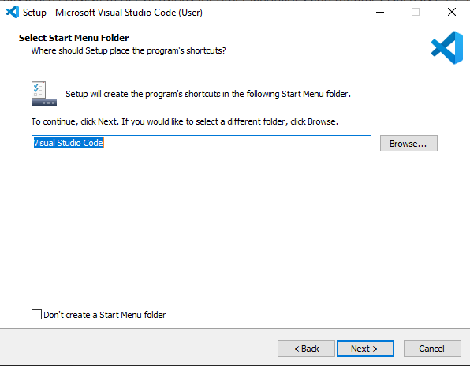

1. Leave the selections as default. Click on **Next**.

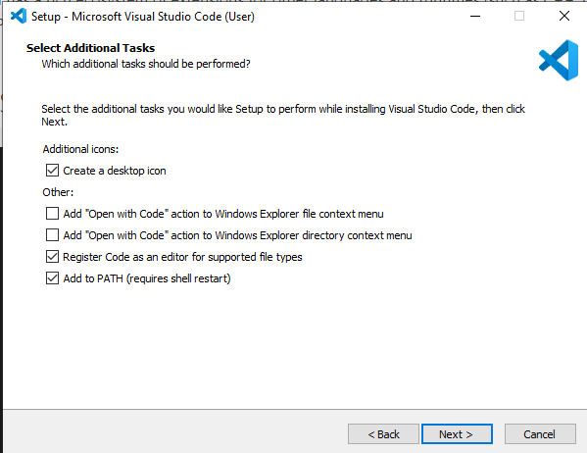

1. Click on **Install**

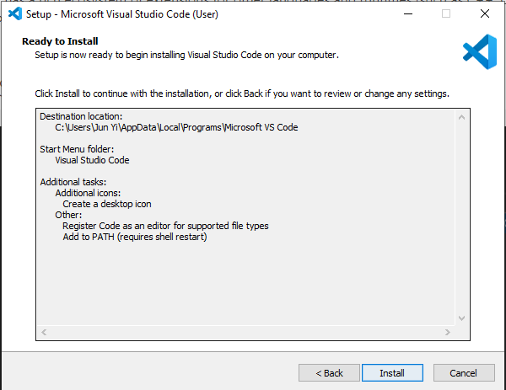

1. The installation will begin. Once installation is completed, click on **Finish**

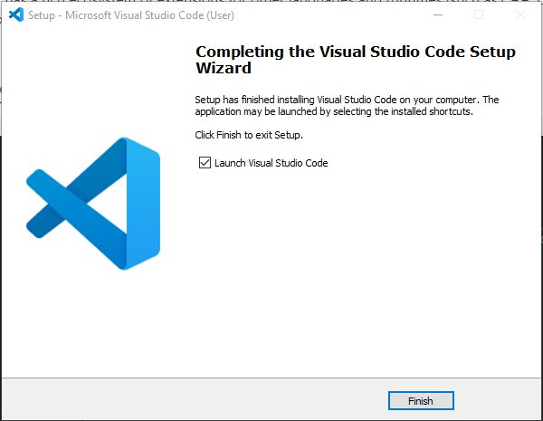

1. Voilà

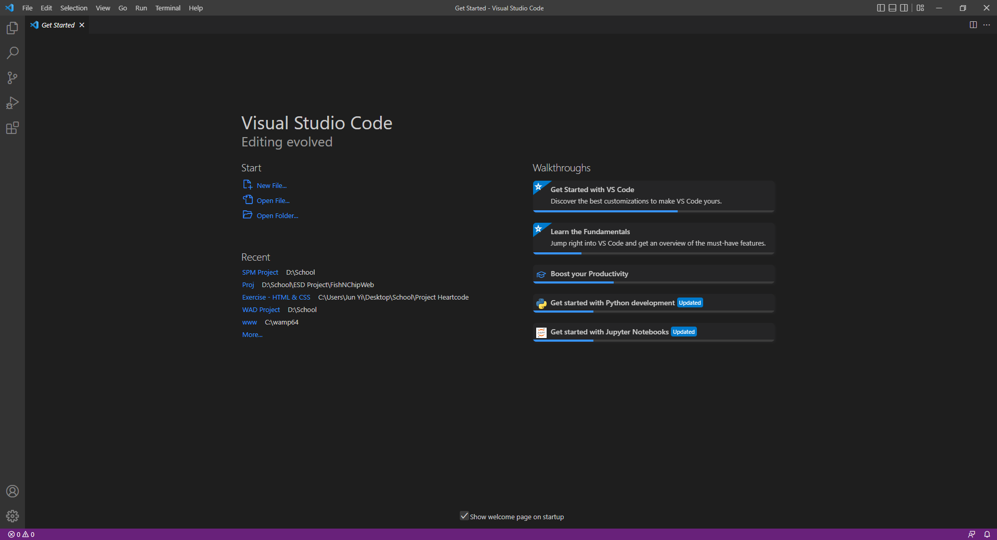

If you face any issues in the installation process, please seek help from the trainers! :-)

See you soon!

### 

### Installation Guide for Mac

1. Go to <https://code.visualstudio.com/download>
2. Click on the **Mac** option on the download site

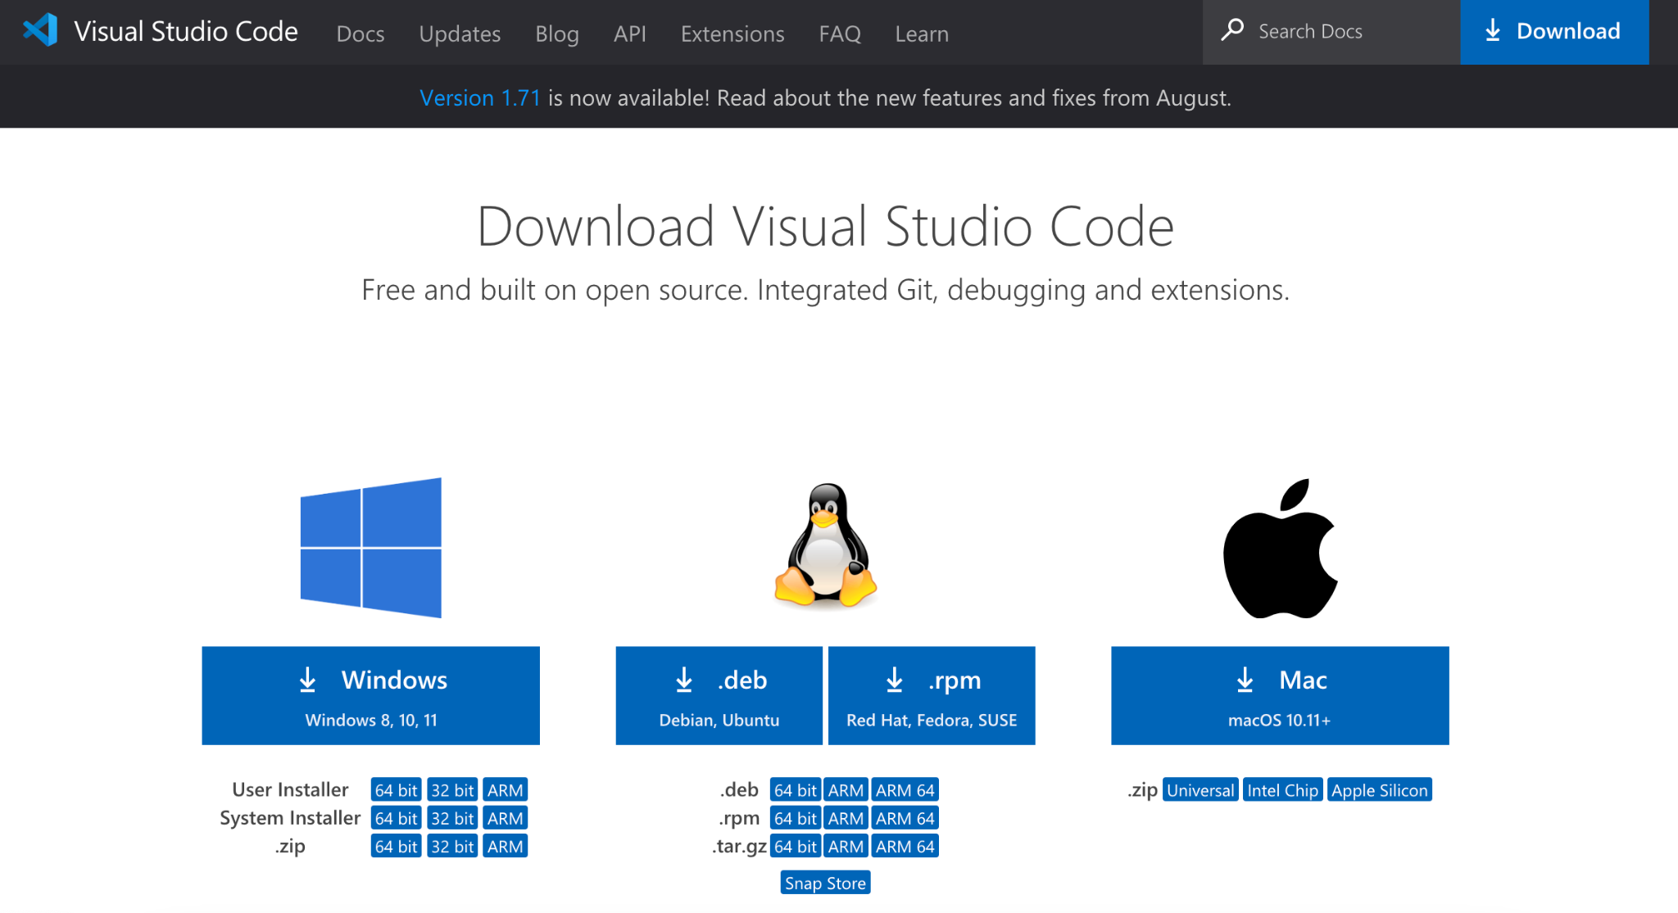

1. Download Visual Studio Code for Mac
2. After clicking on the Mac option on the download site, it will download a zip file, as shown below:  
   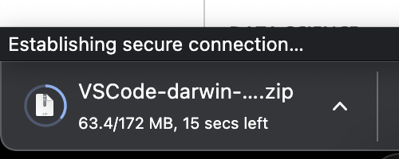
3. Double-click on the downloaded zip to reveal “Visual Studio Code 2”.
4. A warning may pop up, click **“Open”**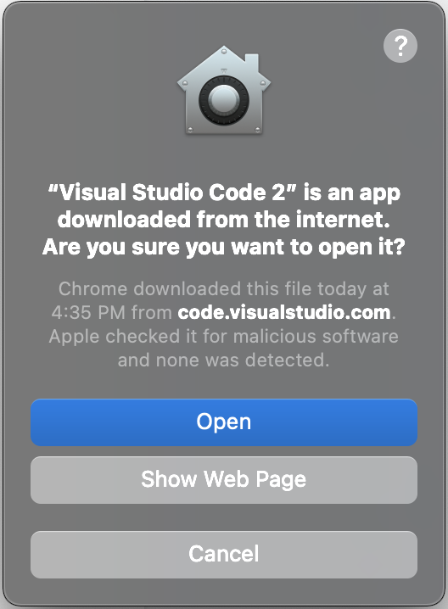
5. Double click on the "Visual Studio Code" to open.
6. Voilà

If you face any issues in the installation process, please seek help from the trainers! :-)

See you soon!